COOKING APP - RECIPE SUGGESTION DOCUMENTATION

**Team ID : SWTID1741174569157257**

**Team Size : 4**

**Team Leader : NIRANJAN I E-Mail-niranjannika281@gmail.com**

**Team member : PRIYA J D E-mail-jdpriya1429@gmail.com**

**Team member : SRIKALA S E-mail-Srikalasrikala82@gmail.com**

**Team member : VEERAPANDIYAN M E-mail-veerapandiyan364@gmail.com**

# 1.INTRODUCTION

The **Cooking App** is a user-friendly platform designed to help individuals discover new recipes based on the ingredients they have. Whether users are home cooks, food enthusiasts, or professional chefs, the app provides personalized recipe suggestions, making meal planning easier and more efficient.

With an intuitive interface, users can search for recipes by entering available ingredients, ensuring minimal food waste while maximizing creativity in the kitchen. The app integrates **video tutorials**, allowing users to watch step-bystep cooking guides for better execution. Additionally, users can save their favourite recipes, create shopping lists, and access nutritional information for a healthier diet.

The app utilizes a robust **technology stack**, including **React** for the frontend, **Node.js and Express** for backend operations, and a **recipe API** for fetching diverse meal suggestions. **Firebase authentication** may be integrated to enable user accounts and personalized recommendations.

Beyond its core features, the Cooking App aims to introduce AI-powered suggestions and community-driven recipe sharing in future updates. Designed to be accessible on both web and mobile platforms, this app enhances cooking experiences while promoting healthier, more efficient meal planning. Whether for beginners or experienced cooks, the Cooking App is a must-have kitchen companion.

# 2.Project Scope

The **Cooking App** is an innovative platform designed to help users discover recipes based on available ingredients. It caters to **home cooks, professional chefs, and food enthusiasts**, making meal planning easier and more efficient. With a user-friendly interface, the app suggests recipes, provides step-by-step cooking tutorials, and allows users to save and share their favorite meals.

**2.1 Project Scope**

The app includes several key features to enhance the cooking experience:

* **Ingredient-Based Recipe Suggestions**: Users can input available ingredients, and the app will generate suitable recipes, reducing food waste and maximizing creativity.
* **Video Tutorials**: Integrated video guides provide step-by-step cooking instructions, making it easier for users to follow complex recipes.
* **Save and Share Recipes**: Users can bookmark favorite recipes and share them with family or friends via social media or messaging platforms.
* **Nutrition Information**: Each recipe includes detailed nutritional insights, helping users make healthier food choices.

The app leverages **modern technologies**, including **React** for the frontend, **Node.js and Express** for backend operations, and a **recipe API** for fetching diverse meal options. With a vision for **future enhancements**, such as AIpowered recommendations and a community-driven recipe-sharing feature, the Cooking App aims to become an essential tool for all food lovers.

# 3.Technology Stack

The **Cooking App** is built using a modern and scalable technology stack to ensure a seamless user experience.

Frontend

The frontend is developed using **React**, a popular JavaScript library for building dynamic and interactive user interfaces. **React Router** is used for efficient navigation between pages, ensuring a smooth user experience. **Axios** handles API requests, enabling fast and reliable data fetching from external sources. Additionally, **React Icons** provide visually appealing icons, while **React YouTube** integrates video tutorials for step-by-step cooking guidance.

Backend

The backend, if implemented, is powered by **Node.js** with **Express.js**, a lightweight framework that simplifies server-side operations. It handles API requests, authentication, and data processing efficiently.

Database

For data storage, the app can utilize **MongoDB** for a NoSQL, flexible database solution or **Firebase** for real-time data synchronization and user authentication. Firebase also offers cloud hosting and push notifications, enhancing user engagement.

API Integration

The app fetches recipe data from a **Recipe API**, allowing users to access a

diverse range of recipes, including ingredients, cooking steps, and nutrition details. Future improvements may include AI-based personalized recommendations and advanced filtering options for enhanced user experience.

# 4.System Architecture

The **Cooking App** follows a structured system architecture to ensure efficient performance and scalability. It consists of three main components: **Frontend, Backend, and Database**.

Frontend

The frontend is responsible for handling **user interactions and UI display**. Built using **React**, it provides a seamless user experience with interactive components. Users can search for recipes, view details, watch tutorials, and save their favorite meals. The frontend communicates with the backend via **API requests** to fetch recipe data and store user preferences.

Backend

The backend, developed with **Node.js and Express.js**, acts as a bridge between the frontend and the database. It processes **API calls**, manages **user authentication** (if applicable), and handles **business logic** such as filtering recipes based on user inputs. The backend ensures efficient data retrieval from external APIs and smooth communication with the database.

Database

The database stores **user preferences, saved recipes, and authentication data** (if Firebase or MongoDB is used). This allows users to access their favorite recipes anytime, ensuring a personalized experience. The database structure is designed for quick data access and scalability, making it suitable for future enhancements like AI-powered recommendations and meal planning features.

# 5.Installation & Setup

Setting up the **Cooking App** is a straightforward process that requires a few simple steps. Follow the guide below to install and run the application on your local machine.

## 1. Clone the Repository

First, download the project files by cloning the GitHub repository. Open a terminal and run:

bash CopyEdit git clone <repository-url>

Replace <repository-url> with the actual GitHub repository link.

## 2. Install Dependencies

Navigate to the project directory and install the required dependencies using **npm**:

bash Copy Edit cd CookingApp npm install---

This will download all necessary packages listed in the **package.json** file.

## 3. Start the Application

To launch the application in development mode, run:

Bash

Copy Edit npm start---

This will start a local server, and you can access the app in your web browser at **http://localhost:3000/**.

## Additional Setup (If Required)

* If the app uses a database like **Firebase** or **MongoDB**, configure the environment variables accordingly.
* If deploying, build the project using npm run build and deploy it on a hosting platform like **Vercel** or **Firebase Hosting**.

# 6.Project Structure

The **Cooking App** follows a well-organized directory structure to maintain clean and efficient code. Below is an overview of its main components:

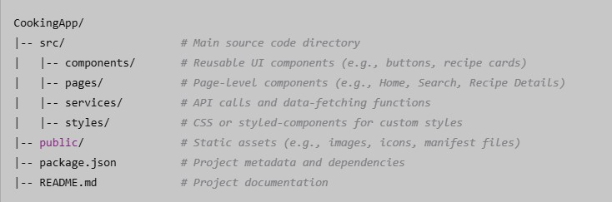

## Key Directories & Files

* **src/components/**: Contains reusable UI elements such as buttons, navigation bars, and recipe cards.
* **src/pages/**: Includes different page components like the home page, recipe details, and favorites page.
* **src/services/**: Manages API requests for fetching recipes and user data.
* **src/styles/**: Holds global CSS files or styled-components for UI styling.
* **public/**: Stores static assets like images, icons, and metadata for web performance optimization.
* **package.json**: Defines project dependencies, scripts, and configurations.
* **README.md**: Provides documentation on how to install, set up, and use the application.

This structure ensures scalability and maintainability, making it easy for developers to add new features or update the app efficiently.

# 7.User Interface

The **Cooking App** is designed to provide a seamless and user-friendly experience, allowing users to easily discover, save, and follow recipes. The app's interface is intuitive, visually appealing, and structured to enhance navigation.

## Key Screens

1. **Home Screen** o The home screen showcases **trending and recommended recipes** based on user preferences and popular choices. o Users can explore new dishes, view featured meals, and quickly access recipes with high ratings.

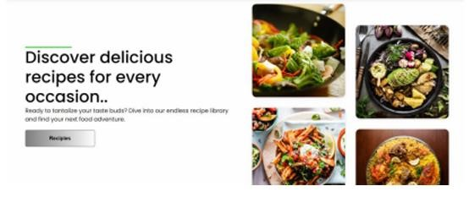

1. **Search Page** o Users can enter available ingredients to receive **personalized recipe suggestions**.
   * The app filters results based on dietary preferences, cuisine type, and cooking time.
   * An advanced search option allows users to refine results for better customization.
2. **Recipe Details Page** o Displays a **step-by-step guide** for cooking, including preparation and cooking times. o Integrates **video tutorials** via YouTube to help users follow along visually.
   * Shows **nutrition facts**, including calorie count, macronutrient breakdown, and health benefits.

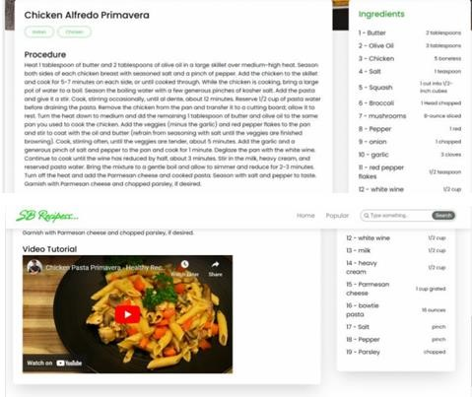

1. **Favorites Page** o Users can **save and access** their preferred recipes for future reference. o Allows easy organization of saved meals into custom collections.

This user-friendly interface ensures a smooth experience for home cooks, professional chefs, and food enthusiasts, making cooking more enjoyable and convenient.

# 8.Testing & Debugging

To ensure a smooth and reliable user experience, the **Cooking App** undergoes rigorous testing and debugging at multiple levels. The testing process includes **unit testing, API testing, and UI testing**, each addressing specific aspects of the application’s functionality.

## 1. Unit Testing

* The app uses **Jest**, a popular JavaScript testing framework, to validate individual **React components** and functions.
* Unit tests check if each component **renders correctly, handles user interactions properly**, and performs expected operations without errors.
* This ensures modular reliability and helps prevent bugs before deployment.

## 2. API Testing

* API endpoints are tested using **Postman** to verify **request and response accuracy**.
* The test process includes **fetching recipes, user authentication (if applicable), and external API integrations** such as the Recipe API and YouTube API.
* Postman helps identify API failures, incorrect data formats, and performance bottlenecks.

## 3. UI Testing

* Manual testing is performed to assess **responsiveness, navigation, and overall usability** on various devices and screen sizes.
* Testing ensures that the app functions smoothly across different browsers, ensuring an optimal **user experience**.

By implementing these testing methods, the Cooking App maintains high performance, reliability, and a bug-free interface for users.

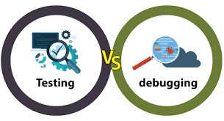

# 9.Conclusion & Future Enhancements

The **Cooking App** is designed to simplify the recipe discovery process by providing ingredient-based suggestions, video tutorials, and nutritional insights.

It enhances the cooking experience for home cooks, professional chefs, and food enthusiasts by offering a user-friendly interface, seamless API integration, and personalized recommendations. The app’s ability to suggest recipes based on available ingredients reduces food waste while promoting creativity in the kitchen.

## Future Enhancements

To further improve the user experience, several enhancements are planned for future updates:

1. **AI-Based Personalized Suggestions** o Implementing **machine learning algorithms** to analyze user preferences and suggest recipes tailored to individual tastes.

o AI will learn from **past searches, saved recipes, and dietary preferences** to offer smarter recommendations.

1. **Meal Planning Feature** o Users will be able to **plan meals for the week** based on dietary goals and ingredient availability. o Integration with **grocery lists** will help users shop efficiently and stay organized.
2. **Community Recipe Sharing** o Introducing a **social feature** where users can **share their own recipes** and cooking tips. o A rating and comment system will allow users to engage with the community, improving recipe discovery.

With these improvements, the Cooking App aims to become a **comprehensive, intelligent, and interactive** platform for all food lovers.